Final Lab Report- Pollinator Observations

Hypothesis:
We hypothesized that the red begonias would attract more bees than the pink begonias because the red begonias are brighter.

Procedure:
Our procedure was to observe four groups of each flower and see how many bees visit each group.

Data:
We went to the school grounds for this pollen lab. We observed at 10:00 A.M. for 20 minutes. It was 64 degrees. The humidity was 71%. The wind was ESE at 1 mph.

Analysis of Data:

 | Begonias
Group | Red | Pink
1 | 4 | 4
2 | 3 | 1
3 | 6 | 3
4 | 7 | 6

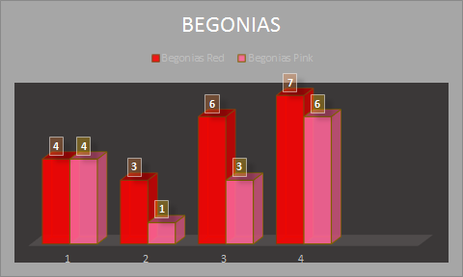

Conclusion:
The red begonias attracted a few more bees than the pink begonias. Our hypothesis was correct.

Pictures:
