Herb your Enthusiasm
AP/ACP Biology
5 November 2018

Title: Examining Starch Levels After Photosynthesis in Various Colors of Light

Purpose:
The purpose of this lab is to examine the role of different wavelengths of light in photosynthesis through observing starch levels in parsley leaves. The leaves will be placed under different colors of light and tested with an iodine solution to indicate a presence of starch. Half of the leaves on each plant will be covered in aluminum foil, using these as the controlled variable since they will not be photosynthesizing and should not produce any starch. Entire parsley plants will be used because the attached leaves will continue photosynthesis.

Background:
With this research topic, one experiment tested starch in plants because plants make food during photosynthesis and the glucose not used is stored as starch in the tissues of the plant. This experiment can determine whether or not photosynthesis occured by measuring carbohydrate production. By boiling isopropyl alcohol and placing leaves in it and then staining them with iodine, the experiment tested to see if starch was present. The boiled water broke down the cell walls of the leaf while the alcohol broke the chlorophyll down, which removed the color green from the leaf. With the iodine, if the plant turned a deep blue or black color, then starch was present in the leaves, which means the plant performed photosynthesis. Another experiment found that the leaves became soft and brittle after being boiled. That experiment used ethanol and saw that it changed from being colorless to the color green, likely because the green was removed from the plants. When starch was not present, the solution of iodine did not experience a color change and remained a brown color, but, when starch was present, the solution changed from the brown color to a bluish-black color. The leaves are boiled because it allows iodine to react with the leaves and the starch in them. The chlorophyll is removed by the ethanol to observe if photosynthesis happened and starch is present. Lastly, in this experiment, the leaves were washed with water to rehydrate them. Overall, other experiments and scientists have determined that starch is produced during photosynthesis and manipulating plants and finding starch means they underwent photosynthesis. Photosynthesis produces glucose, which changes to starch and is stored.
Works Cited
“Test for Starch in Plants.” Home Science Tools, 2018,
learning-center.homesciencetools.com/article/test-for-starch-photosynthesis/.
“Testing a Leaf for Starch.” Brilliant Biology Student, 2015,
brilliantbiologystudent.weebly.com/testing-a-leaf-for-the-presence-of-starch.html.

Variables:
- The independent/manipulated variable was the three different colors of light. The experiment used different colored light bulbs and set one plant under a blue light, a green light, and a white light.
- The dependent/responding variable was the absence or presence of starch in the leaves which measured by color change when using iodine.
- The constant variables were the location and time of the experiment, light wattages, plants and leaves, iodine and isopropyl alcohol, foil, and equipment.
- The control group was the leaves covered with foil because they would not photosynthesize or produce any starch regardless of which colored light they were under. The experimental group was the uncovered leaves under the three lights.

Hypothesis:
If parsley plants are under blue, white, and green light, the plants will demonstrate the most starch (because more photosynthesis = more glucose) under blue, then white, then green and there will be little to no starch in the leaves in the darkness under the foil. This will be evidenced by color change in the leaves.

Materials:
- Safety goggles
- Hot plates
- Hot water bath
- Gloves
- Beakers
- Thermometer
- Aprons
- 70% Isopropyl Alcohol
- Water
- 3 Parsley Plants
- Aluminum Foil
- Tweezers
- Iodine
- White light bulb
- Blue light bulb
- Green light bulb
- Lamps

Procedure:
- Safety goggles, aprons, and heat resistant gloves were worn throughout the procedure.
- Parsley plants were left under three different colors of light, green, blue, and white, for 72 hours.
- Half of each plant’s leaves were covered with aluminum foil to prevent photosynthesis from taking place.
- 70% isopropyl alcohol was boiled in a beaker.
- Water was heated to a boil on a hot plate.
- The parsley leaves were torn off of the plant, placed into the boiling water, and boiled in water for two minutes.
- The leaves were removed from the water and placed in a dish with the boiling isopropyl alcohol.
- After one minute, the leaves were removed from the alcohol and placed on a paper towel.
- The leaves were covered dropwise by iodine solution and after five minutes, it was determined if starch was present or not.

Data and Results:
Monday, 11/6/18 (72 hours after starting photosynthesis):
Different Wavelengths of Lights Effects on Percentage of Leaves Showing Starch Presence
Type of light: | White w/o foil: | White w/ foil: | Blue w/o foil: | Blue w/ foil: | Green w/o foil: | Green w/ foil:
Presence of Starch (Y/N): | Yes | No | Yes | No | No | No
Number of leaves | 17 | 11 | 14 | 13 | 14 | 9
Number of leaves with starch present | 17 | 0 | 6 | 0 | 2 | 0
Percentage of leaves with starch present | 100% | 0% | 43% | 0% | 14% | 0%

Calculations:
To find the percentage of leaves showing starch presence, the number of leaves showing starch were divided by the total number of leaves and multiplied by 100.
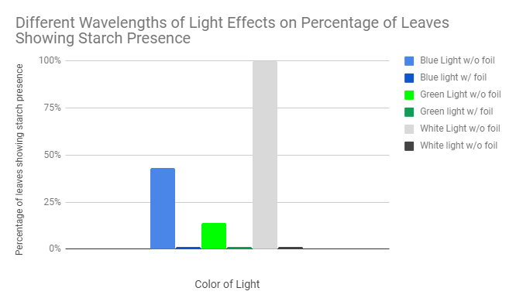
Graphical Analysis:

Results:
The graph shows that the largest presence of starch was in the plants under the white light, 100% (17/17) of the leaves under the white light showed a presence of starch. The plants under the blue light had 43% (6/14) of leaves show a presence of starch, slightly more than the 14% (2/14) of the plants under the green light. There was only one leaf under green light that showed a presence of starch.

Conclusion:
The purpose of this experiment was to examine how different colors of light affect the production of starch, a polymer of glucose, during photosynthesis. Chlorophyll was extracted from the leaves and they were covered in iodine solution. If glucose, which is stored in the form of starch, was present, the leaves would turn a deep blue or black color and there would be proof of photosynthesis. If the leaves stayed brown (the color of the iodine solution), there was no starch present. It was hypothesized that all of the leaves under a light would photosynthesize and produce starch. The plants covered in foil would not produce any starch. The hypothesis supported the results of the leaves under blue, white, and no light. Leaves under blue light were expected to produce the most starch because plants mostly absorb blue, indigo, and violet rays. However, it was found that white light created the most starch and the parsley plant’s leaves all turned blue. There was 43% of starch present on the leaves under blue light and 14% on the leaves under green light. There was no starch present in the lights covered in foil.
In this experiment, there were a few possible sources of error. One could have been inadequate coverings of the leaves covered in foil. When some of the leaves were covered in foil, there could have been spaces where they were exposed to the light and they could have photosynthesized. Since none of the leaves covered in foil showed a presence of starch, this is only a theoretical problem. Another source of error could have been not boiling the leaves completely, not leaving them in the alcohol long enough, or not staining them with enough iodine. These errors could have caused starch to not turn blue even if the starch was present. A final source of error was one leaf under green light appeared as though starch might have been produced. This was not included in the final results because it was most likely a human error and there was only one leaf out of the many others. This could have been due to a simple mixup between leaves or it could have photosynthesized during the time it took to move the plant from the green light to the boiling water.
From this experiment, it was learned that parsley plants photosynthesize and produce the most starch under white light. Since white light includes every color of light, this make sense because the plants could absorb the normal blue and violet rays as well as the red wavelengths of light. The blue light only allowed the plant to absorb blue rays and left out any red rays the plant might utilize. Plants absorb no green light and the experiment also supported this. Another question that could be investigated next could be testing other colors of light, like red or black light. In testing red light, data could be collected on how many leaves produced starch or how much starch was produced (if easy to tell from iodine stains). Another idea could be to test other effects different colors of light have on plants. The plants could be left under colored lights for a longer period of time and then measured for length or another physical feature.

