- Research report

A. Review in general

    - Anatomy-​The ​Arabidopsis thaliana ​is most notably used in agricultural research because of its because it; produces, develops and responds like most crops, is easy to grow, inexpensive, produces many seeds ("The Role of Arabidopsis in Plant Science Research”) and has a small genome ("What is a genome? - Genetics Home Reference - NIH."). In this, the anatomy of this organism is typical for most crops. After germination, plants begin to grow roots, which allow the plant to absorb the water and nutrients necessary for further growth. After the roots have been developed enough to support the plant and its growth, the stem begins to grow. In this stem, there is xylem and phloem. Xylem transfers nutrients and water up the plant, while the phloem is developed along with the leaves as it transfers sugar created by the leaves throughout the rest of the plant. The development of leaves after the stem is where photosynthesis primarily takes place. Photosynthesis in ​Arabidopsis thaliana ​is uniform to other crops. Lastly, the development of flowers leads to the process of reproduction. This organism contains both pollen in the stamen and an ovary in the pistil. See also: ("Petiole.") ("Plant Morphology The Parts of a Flower.") ("silique.") ("cauline.") (​https://www.researchgate.net/figure/Life-cycle-of-Arabidopsis-thaliana-Th e-mature-plant-possesses-primary-and-secondary_fig1_8937186​)
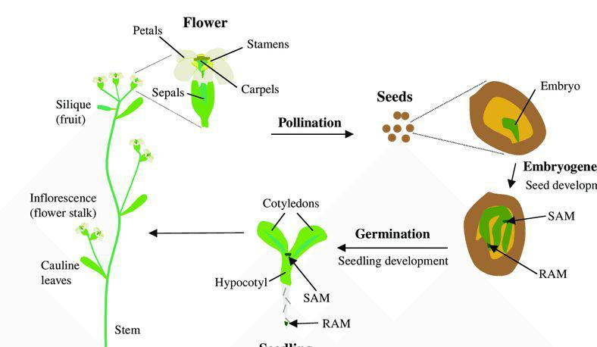

2. Physiology

- Plant Physiology is Is the study of plants and and how different parts of the plant function. In our case of introducing toxic levels of zinc to the plant ​Arabidopsis thaliana, many symptoms can be observed. First off, many changes in color are observed. Dark brown colored spots or blotches on older leaves are present when zinc toxicity occurs, and in severe cases, red pigmentation throughout the leaves, especially in the vines, is

present(O'Sullivan) . 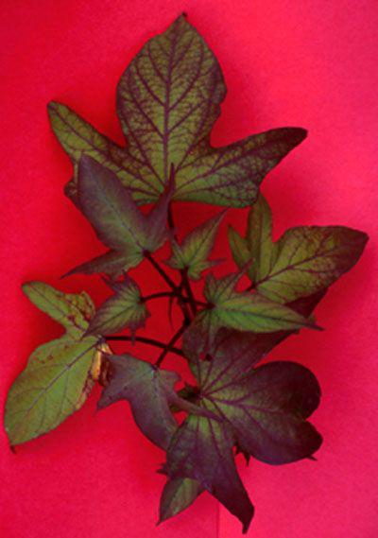

- In addition to that, stunted growth is observed when zinc toxicity occurs. The more zinc that is present in the plant, the shorter the plant will be.

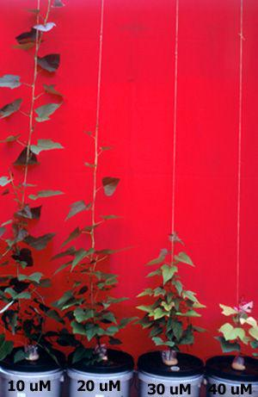

https://keys.lucidcentral.org/keys/sweetpotato/key/Sweetpotato%20Diagnotes/Media/Html/TheP roblems/MineralToxicities/ZincToxicity/Zn%20toxicity.ht

- Plant ecology-​Plant ecology is a subdiscipline of ecology which ​studies the distribution and abundance of plants​, the effects of environmental factors upon the abundance of plants, and the interactions among and between plants and other organisms. Within our experiment we will be testing an increase zinc content. This is the relation of the environmental factor (extra zinc) and plants and genetically modified. We will measure changes that occur from this relation in our scientific journal

https://www.researchgate.net/figure/Schematic-of-Arabidopsis-thaliana-nectarium-Arabidopsis-fl owers-have-four-nectaries-that_fig1_26672832
- Effect of the mutation​​Columbian Wild type

-Needs a specific amount of zinc (depending on age) to grow and function correctly (Bloodnick) (Carter)

nca-1-1

-This mutant has a deficient gene in protein coding (Yin), and so it will not respond respectfully to environmental stresses (Hackenberg). Extra zinc will put this plant to distress and cause it will furthermore make the plant work more out of pace as it already has a deficiency in the protein coding, this prevents the correct protein folding and puts everything out of work.

zip-2

-This mutant has a deficient gene in cellular transport, greatly lessening the amount of passive/active vesicular transport through the plasma membrane, and thus it may not accomplish transporting all the extra zinc in the soil (Hunter). This might be a solution to the world of extra zinc in the soil as if it cannot move the toxic amounts of zinc into the cells then it avoids that problem of zinc toxicity. Also having an abundant amount of zinc can make the plant deficient in other II ions as there is no room for them(​"Gene : AT3G54360 A. thaliana.")​.

- What is the gap in research

  - The gap in the research is finding a good solution to extra zinc in the soil. As there are many different variants of the genes and test every single one would be very gruesome and thus making this plant (arabidopsis thaliana a research plant) and testing it and pushing it to its limits allows us to see what varied genes provide a better chance at success in an environment of a high concentration of zinc in the soil. An example of a similar gene being tested is https://www.ncbi.nlm.nih.gov/pmc/articles/PMC2890486/​Here they test other Zip variants and their succession to a defiency of zinc in the soil. This goes to show that there are many different variations and testing each and every gene to see which one provides the best outcomes to certain environmental stresses allows up to maybe come up with a possible solution to areas with that certain environmental stress and let them genetically change their crops on that certain gene allowing them to get the best harvest and providing food for the world despite having certain environmental stresses.

- Relevance of plant research​Relevance- The ​Arabidopsis thaliana ​has been prominently used in agriculture research in the United States. In fact, organizations such as the; U.S. Department of Agriculture, Department of Energy, and National Institutes of Health have invested a collective sum of over $7.5 million in 1990 and $22 million in 1993 for research on the ​Arabidopsis thaliana ​("The Role of Arabidopsis in Plant Science Research.")​. ​Not only this, but the data found from this experiment could assist other scientists and farmers in the agriculture field. This is because our data will depict the stages of zinc toxicity and how to identify these symptoms along with how certain mutants are impacted by increased zinc levels. The data from this experiment will also aid in the determination of to what extent the zinc levels in the soil impact the growth of the ​Arabidopsis thaliana ​and its mutants.

- How can this have an impact on the broader world​- World impact- While zinc deficiency is prominent in different areas of the world, in Mexico there is a significant problem with zinc toxicity. The reason that this has such a strong impact in this area is because of what the houses are built of and its climate. In Mexico, the houses are built with metal for their roofs. This is because of the heavy rain and changing climate. However, the building of these roofs and the materials used to maintain them are often impacted by the climate. It is known to be very humid in Mexico, and this leads to the materials running off the roof and onto the plants in the ground(Veleva). This leads to zinc toxicity in the plants.

- Bibliography

  - Bloodnick, Ed. "Role of Zinc in Plant Culture." Promix, 5 Oct. 2018, www.pthorticulture.com/en/training-center/role-of-zinc-in-plant-culture/. Accessed 4 Oct. 2019.

  - C, Hunter, et al. The Arabidopsis heterochronic gene ZIPPY is an ARGONAUTE family member. Pennsylvania, Plant Science Institute, Department of Biology, 30 Sept. 2003. PubMed, www.ncbi.nlm.nih.gov/pubmed/ 14521841?dopt=Abstract. Accessed 7 Oct. 2019.

  - Carter, Clay J., et al. "Uncovering the Arabidopsis thaliana nectary transcriptome: investigation of differential gene expression in floral nectariferous tissues." ResearchGate, Ijad Madisch Sören Hofmayer Horst Fickenscher, Feb. 2009, www.researchgate.net/figure/Schematic-of-Arabidopsis-thaliana-nectariu m-Arabidopsis-flowers-have-four-nectaries-that_fig1_26672832.

  - "cauline." Vocabulary.com, Mark Tinkler, www.vocabulary.com/dictionary/cauline.Accessed 4 Oct. 2019.

  - Chaudhury, Abdul M., et al. Fertilization-independent seed development in Arabidopsis thaliana. 15 Apr. 1997. Proceedings of the National Academy of Sciences, www.pnas.org/content/94/8/4223.short. Accessed 3 Oct. 2019.

- "Gene : AT3G54360 A. thaliana." ThaleMine, V. Krishnakumar, 13 June 2017, apps.araport.org/thalemine/portal.do?externalids=AT3G54360. Accessed 8 Oct. 2019.

- "Gene Ontology and GO Annotations." QuickGO, www.ebi.ac.uk/QuickGO/term/GO:0071577. Accessed 8 Oct. 2019.

- Hackenberg, Thomas, et al. Catalase and NO CATALASE ACTIVITY1 Promote Autophagy-Dependent Cell Death in Arabidopsis. Plant cell, www.plantcell.org/lens/plantcell/25/11/4616. Accessed 8 Oct. 2019.

- Juul, Trine, et al. "The in Vivo Toxicity of Hydroxyurea Depends on Its Direct Target Catalase." Journal of Biological Chemistry, 9 July 2010, www.jbc.org/ content/285/28/21411. Accessed 8 Oct. 2019.

- Koyama, Kohei, and Teruhisa Masuda. https://www.nature.com/articles/s41598-018-34772-2. Nature.com, 6 Nov. 2018. Nature Research Journal, www.nature.com/articles/s41598-018-34772-2 .

- Krishnakumar, V. ThaleMine: Gene AT3G54360 A. thaliana. ThaleMine, 13 June 2017, apps.araport.org/thalemine/portal.do?externalids=AT3G54360.

- Li, J., et al. A chaperone function of NO CATALASE ACTIVITY1 is required to maintain catalase activity and for multiple stress responses in Arabidopsis. American Society of Plant Biologists, 27 Mar. 2015. PubMed.gov, www.ncbi.nlm.nih.gov/pubmed/25700484. Accessed 8 Oct. 2019.

- "Locus: AT1G69440." Tair, 3 Apr. 2016, www.arabidopsis.org/servlets/ TairObject?name=AT1G69440&type=locus. Accessed 8 Oct. 2019.

- "Locus: AT3G54360." Tair, 7 July 2015, www.arabidopsis.org/servlets/ TairObject?name=AT3G54360&type=locus. Accessed 8 Oct. 2019.

- Milner, Matthew J., et al. Transport properties of members of the ZIP family in plants and their role in Zn and Mn homeostasis. 4 Oct. 2012. Vol. 643, No. 12. Journal of Experimental Botany, www.ncbi.nlm.nih.gov/pmc/articles/ PMC3528025/pdf/ers315.pdf. Accessed 8 Oct. 2019.

- "Name / Stock Number: CS24282." Arabidopsis Biological Resource Center, abrc.osu.edu/stocks/45155. Accessed 8 Oct. 2019.

- "Name / Stock Number: CS68673." Arabidopsis Biological Resource Center, abrc.osu.edu/stocks/386361. Accessed 8 Oct. 2019.

- O'Sullivan, Jane. "Zinc toxicity." Sweet Potato Diag Notes, keys.lucidcentral.org/keys/sweetpotato/key/Sweetpotato%20Diagnotes/M edia/Html/TheProblems/MineralToxicities/ZincToxicity/Zn%20toxicity.htm. Accessed 7 Oct. 2019.

- "Petiole." Dictionary.com, www.dictionary.com/browse/petiole. Accessed 4 Oct. 2019.

    - "Plant Morphology The Parts of a Flower." American Museum of Natural History, Ellen Victoria Futter, www.amnh.org/learn/biodiversity_counts/ident_help/ Parts_Plants/parts_of_flower.htm.

    - "The Role of Arabidopsis in Plant Science Research." National Science Foundation, www.nsf.gov/bio/pubs/reports/arabid/chap1.htm. Accessed 4 Oct. 2019.

    - "silique." Dictionary.com, Erin McKean, www.dictionary.com/browse/silique.

    - Accessed 4 Oct. 2019.

    - "Tetratricopeptide repeat-containing domain." InterPro, www.ebi.ac.uk/interpro/entry/InterPro/IPR013026/. Accessed 8 Oct. 2019.

    - Veleva, L., et al. Zinc precipitation runoff from galvanised steel in humid tropical climate. 18 July 2013. Taylor & Francis Online, www.tandfonline.com/doi/abs/10.1179/174327809X457030. Accessed 8 Oct.

    - "What is a genome? - Genetics Home Reference - NIH." U.S. National Library of Medicine, 1 Oct. 2019, ghr.nlm.nih.gov/primer/hgp/genome. Accessed 4 Oct. 2019.

    - Yin, Qian, and Hao Wu. "Ring Finger Domain." ScienceDirect, www.sciencedirect.com/topics/biochemistry-genetics-and-molecular-biolo gy/ ring-finger-domain. Accessed 8 Oct. 2019.

- Research question

  - Discuss aims of study: to determine the impact of zinc levels on the ​Arabidopsis thaliana ​and its mutants

  - Specific sentence to describe what should be accomplished: identifying the extent of the impact on added zinc along with recording each stage of

- Research methods A. Hypothesis​:

Controlled Group

  - Colombian Wild Type is expected to grow relatively normally (in respect to normal height, color, etc.) Germination is expected to be relatively normal (at least 20 out of the 30). The colors of the plant and of the leaves are anticipated to be standard (green, no discoloration). The overall conditions of the plant are believed to be healthy and the height of the plant is expected to be uniform.
  - The ​nca1-1​mutant is expected to be incredibly similar to the Colombian Wild Type, with the possibility of more growth due to advancements in its control.
  - The ​zip-2​mutant is foreseen to grow less adequately than the Colombian Wild Type and nca1-1​mutant. This is because of the silencing of genes, which will lead to more unhealthy conditions in the plant. Other than that prediction, growth is anticipated to be similar to the Colombian Wild Type and ​nca1-1​mutant.

Increased Zinc Groups

- Colombian Wild Type is expected grow in a less than adequate way. Germination is expected to be lower than the controlled groups due to the more acidic soil. The colors of the plants are expected to be discolored in a multitude of different ways (brown spots, etc). The overall health of the plants is expected to be substandard and the plant is expected to be stunted in growth.

- While there is not much research on the effects of this mutation on the nca1-1 mutant, nca1-1​mutant is expected to grow similarly to the Colombian Wild Type. However, the overall health of the plant is expected to be worse. This is because of its ability to metal ion bond as it will cause the plant to take in too much zinc and damage itself.

- The ​zip-2​mutant is also expected to grow similar to the Colombian Wild Type, however its overall conditions are expected to get worse as well. This is because of its already unstable silencing of genes to grow more quickly.

  - General narrative - ​We will test our hypothesis by checking out plants everyday and recording our observations , if we see the leaves to start to have dark brown blotches then we will record it on a day to day basis and by the end of the experiment we will have a detailed write up of what happened everyday and we can compare what happens between all the plants.Allowing up to compare and contrast what happens to the nca1-1,zip-2, and wild type and what happened to the same plants with added zinc in the soil.

  - Experimental design​- Independent variable: Amount of zinc given to the wild type, nca1-1, and zip-2.

Controls of experiment:

- Light

- Temperature

- Time

- Air quality

- Overall environment besides extra zinc

- Same preparation procedure

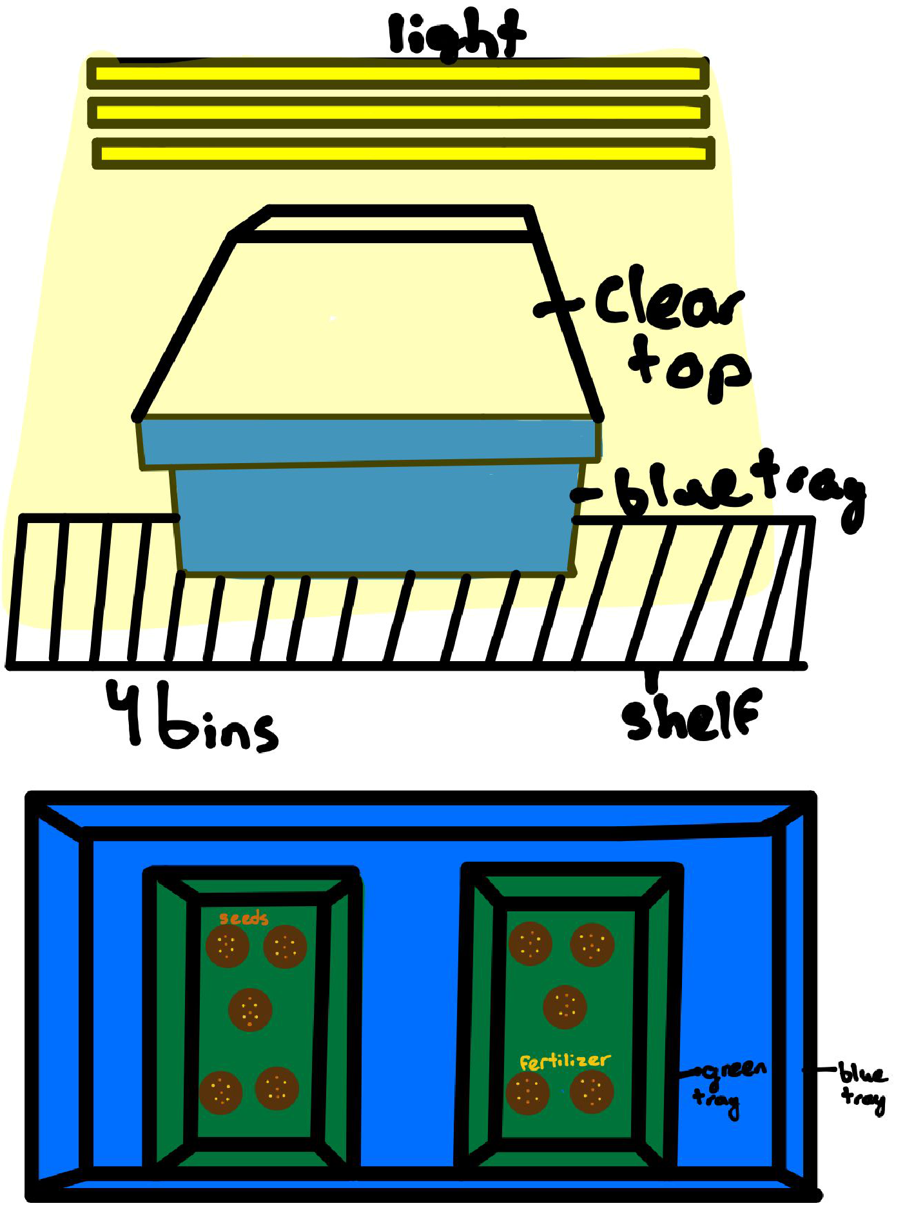

D. Data evaluation​-Dependent variables:
Qualitative

- Colors of the leaves

- Colors of the stem

- Strength of the leaves

Quantitative

- Length of the plant

- Length of the leaves

- Number of leaves

