4. Based off of… A. your group results, B. your class results, C. 9th grade CM Biology results, did we actually see this pattern of traits be expressed? Check the Mustard Seed Master Class Data sheet for this information and use it as evidence in your claims below.
Which level of the population (A, B, and/or C) showed the 9:3:3:1 phenotypic ratio? If your results varied from this ratio, please explain how that could occur with 3 claims. (15 points)
- No
- No
- No
This could have occurred because of the amount of nutrients or what kind of nutrients was in each bottle. Another way this could occurred was the temperature because it varied each day. Lastly, it could have been the amount of water or Gatorade in the bottle.

Quantitative (or Continuous) Traits
Most traits are determined by multiple genes (polygenic). In these cases, the traits tend to vary among individuals in a population along a continuum or range, since they are determined by the interaction of many genes (along with environmental influences). Punnett squares are much more complex to set up (see image below), but the data gathered from an experiment may support its existence.
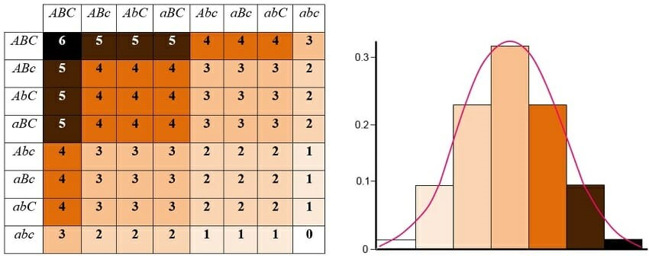 These traits can be quantified, either as a measure (e.g., height, length, days), as a count (e.g., number of leaves), or along a scale (e.g., “hairiness” on a scale of 1-10). So, for instance, plants within a population may vary in height within a range at a particular time in their development. Quantitative traits that can be easily explored in the Mustard Brassica rapa include the following:
• Days for seedlings to emerge
• Height on given days after sowing
• Number of leaves on given days after sowing
• Length of leaves (be sure to create a protocol consistent throughout the class regarding which leaf on the plant will be measured, and how it will be measured)
• Days to flower
• Number of pods

Analyzing Data
5. Please choose ONE of the continuous traits you measured and create a graph. You may choose to graph the using data exclusively from your group dataset, your class data, or the entire CM Biology growth data. Any data we collected from the Mustard experiment will be available to you in a downloadable excel file. Bonus points below will be applied to a missing or low grade from Q3.
1. Your Group Data (15points)
- Your Class Data (1.5x points=22.5points)
- The 9th grade Biology Mustard Data (2xpts=30points)
What trait did you graph? Please paste it below from the excel file.
Average height of my class teams.
What is your x-axis? What is your y-axis?
My x axis is what plant I did and my y axis is the average height of ex: A1 or A2.
LINK TO MY GRAPH: https://docs.google.com/spreadsheets/d/1fS7BORsh2CHf1zIrGSl3dhO1WxHzU2pDIE3nvgp4oYg/edit#gid=0

Graphing data allows you to visualize the trends, and graphing data in different ways can be helpful. Below is a set of hypothetical data graphed with the x-axis representing the plant ID numbers, in ascending order. You can see there is a certain amount of variation in plant height on this day in the population.
Exemplars below:

Bonus: Looking back at your Mustard seed data is there a way to graph your data in a Normal Distribution curve like the image below? Instead of a bar graph, you use a format called a histogram. What must you make the x-axis and y-axis to display that curve? Based on your results, is the phenotypic trait you chose to graph caused by one gene, two genes, three genes, or many genes? Use your graph to justify your answer. (10points will be applied to this Assessment only ) https://www.youtube.com/watch?v=0jFCBbvSS4U
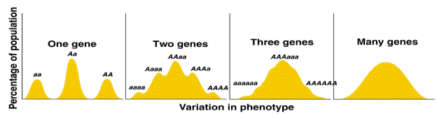
Yes, there is a way to graph my data in a Normal Distribution curve like the image below. The x-axis must look like the genes being graphed and the y-axis must look like number to display how many there are. There are many genes.

6. Please read Concept #1 and 2 other concepts from the list below. In claim-evidence-reasoning fashion, tell me why these concepts are true using the collected data from your mustard experiment, feedback from your mentors, and connections to genetics and evolution we have discussed together. (14 points)
Concepts:
1. An organism exists as an expression of its inherited genes interacting in an environmental context (Phenotype = Genotype X Environment).
This is true because of what we have learned from the punnet squares and how each parent gives an allele to its kid. An organism exists as an expression of its inherited interacting in an environmental context because the punnet squares have shown us that each parent gives one allele and whatever trait is dominant shows in that kid. That is why an organism exists as an expression of its inherited genes interacting in an environmental context.
2. Inheritance of genes occurs via the life cycle of an organism through successful reproduction of offspring.
Inheritance of genes occur via the life cycle of an organism through successful reproduction of offspring. This true because of what we have gone over in class we have learned about how a species environment effects the way it acts and over time the way its children look. That is why this is true.
3. Plants are living, reproducing organisms that live in and are influenced by the environment.
Plants are living because they can reproduce. Reproducing organisms are influenced by the environment. This is true because animals adapt and evolution occurs and changes the way a species acts in an environment and looks to help it survive. We have gone over many situations like this but, one of them that stood out to me was the fish that can turn into female so it can reproduce and make another generation of fish.
4. Plants vary in their phenotypes (traits), and we can observe, measure and analyze this variation by studying populations of plants.
Plants vary in their phenotypes from the certain alleles they get from their parents. We know this is true because of the extensive research of scientists but also our plants have shown this because they are not all the same color and size. This happens because when these mustard seeds have different parents and have different traits like the saying “no two snowflakes are alike.”
5. Science is an active process of inquiry, investigation, and communication.
Science is an active process of inquiry, investigation, and communication because everyone learns something new every day and somethings cannot not be solved lastly to communicate with your peers to help. This is true because scientists learn something new every day even if it is little or something as big as time travel or a new species that can speak English you can never know that is why being a scientist in any field is fun. But there is also some stuff that cannot be solved or something that cannot be figured out. Lastly communication is a huge thing because to be able to understand things clearly you have to say it or talk to someone about it so it sounds clear and understandable.

